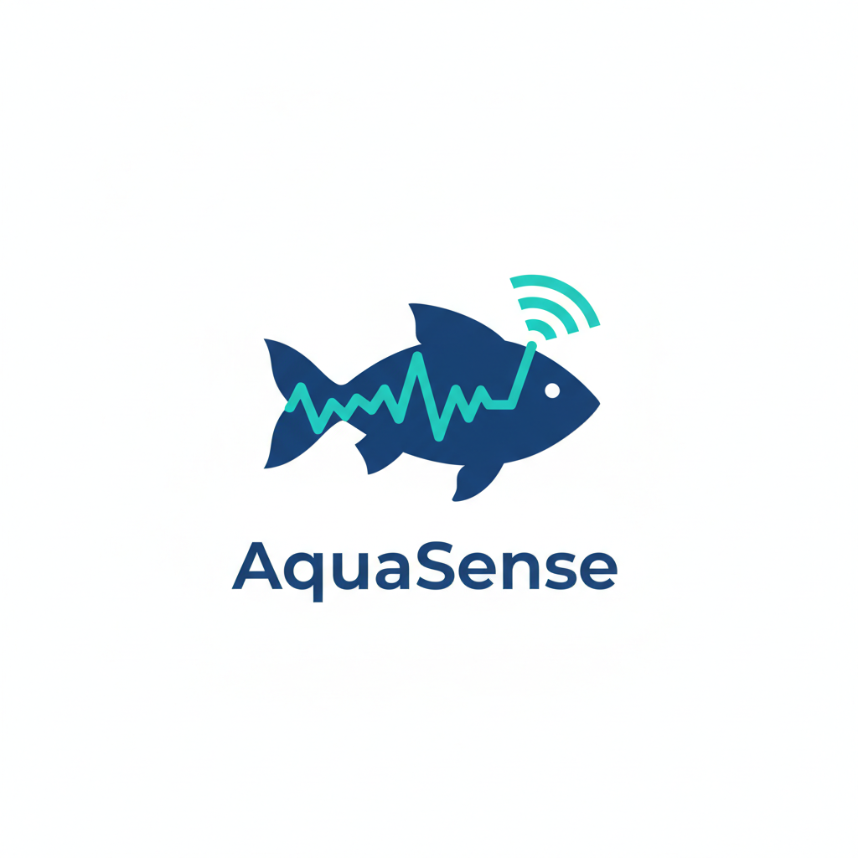  AQUASENSE PROJECT Report  A Report for the Graduation Project from the DEPI Program: An IOT monitoring system of a fish farm | Abstract  This is the Report of the project of an IoT data pipeline for a fish farm, aligning with Egypt's Vision 2030, which continuously monitors critical environmental parameters (e.g., temperature, pH) across 11 fish tanks. The system uses an ETL process and Apache Kafka for real-time alerts and features a web-based dashboard to improve fish farm efficiency and sustainability.

Contents
Introduction 2
Project Features 2
1. Real-time Data Simulation 2
2. ETL System 3
3. Alert System 3
4. Real-time IOT Web-based Dashboard 4
Conclusion 6

Introduction

Aquaense is a project designed and developed for the purpose of contributing to Egypt’s 2030 vision via providing a monitoring system for Egyptian fish farms that is able to handle up to 11 different tanks, for different species, each monitored by up to 8 different sensors. The project is also expandable and can be easily developed to handle many more sensors and tanks.

Project Features
The project is based on 4 features based on the 4 milestones required for the project:
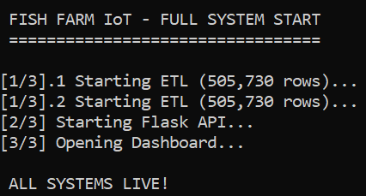

Real-time Data Simulation
Before implementing the real-time IOT data pipeline, it was necessary to have valid test-data that could properly simulate the sensor readings which the system is expected to handle. Instead of generating random data as the simulation data (which would not have been a proper simulation), we followed our technical instructor’s advice and collected online data from actual fish farms and merged it all into one dataset to be the source from which the data is extracted to the pipeline.
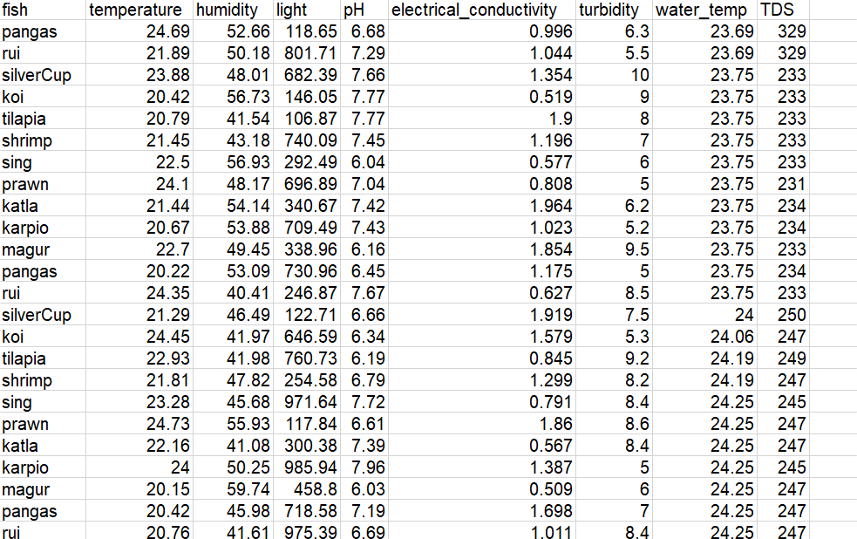

ETL System
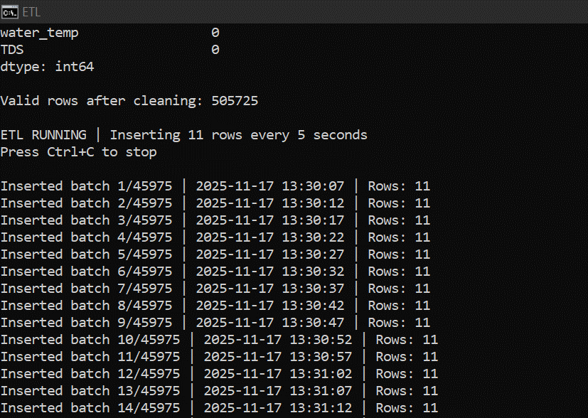
The first stage of the IOT pipeline was developing an ETL system to extract batches from the dataset, transform these batches by giving each sensor reading them a categorical classification as per the project plan, and finally load this data into the database using sqlite3 technology. We made a python ETL script for this stage that performed the ETL process every 5 seconds as instructed in the project document.

Alert System
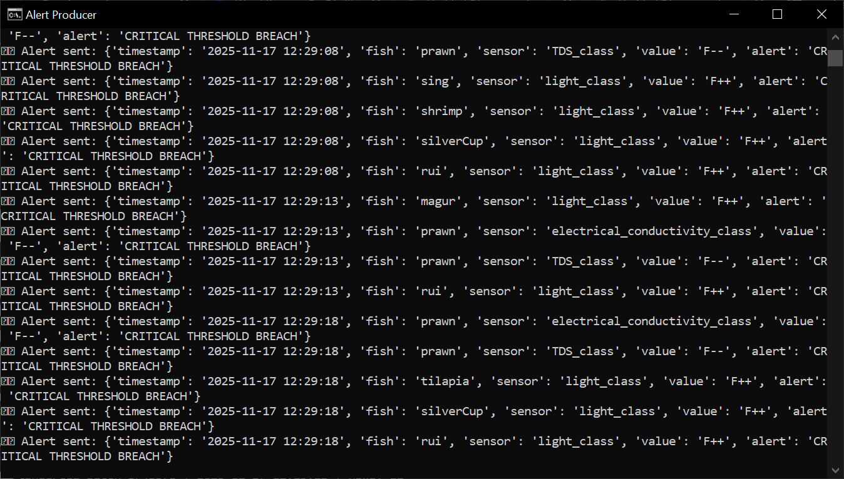
We developed an alert system using Apache Kafka that produces and sends alerts whenever there is a critical threshold breach (when the reading classification is F+, F++, F-, or F--) to warn the workers of the farm about unsafe conditions for the fish once they appear. This feature was implemented through a python script that checked the latest saved readings in the database every 5 seconds for the appearance of critical threshold breaches.
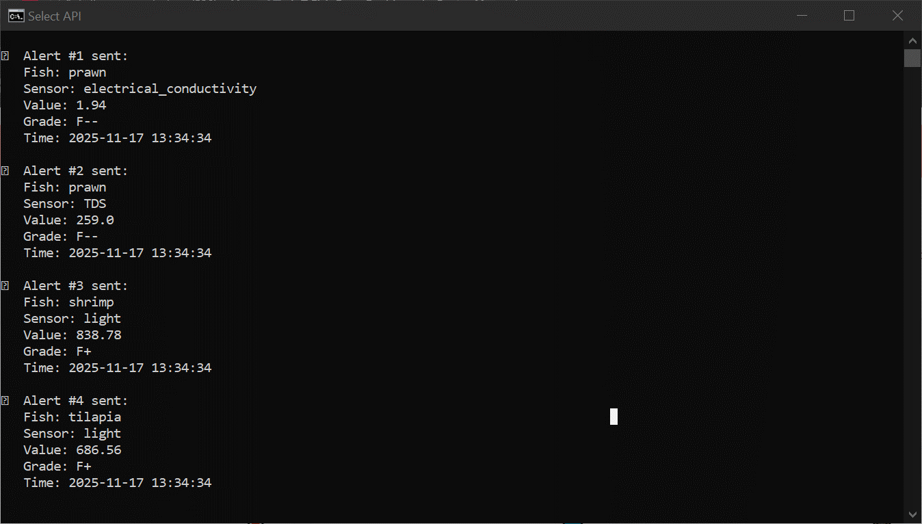

Real-time IOT Web-based Dashboard
This was the final stage of the data pipeline. We built a real- time web-based dashboard using flask server to finally visualize the data stream. We implemented this feature through a python script for the flask server and a webpage showing the data trends, the alerts, and the latest saved values in the database itself.
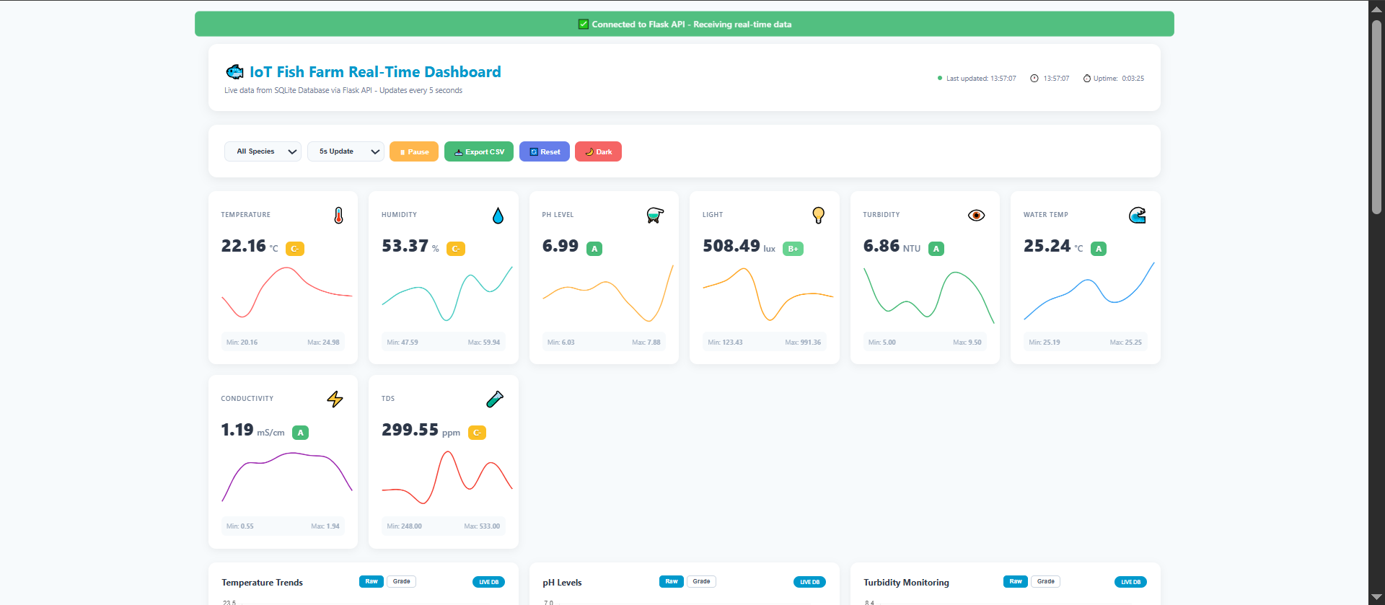
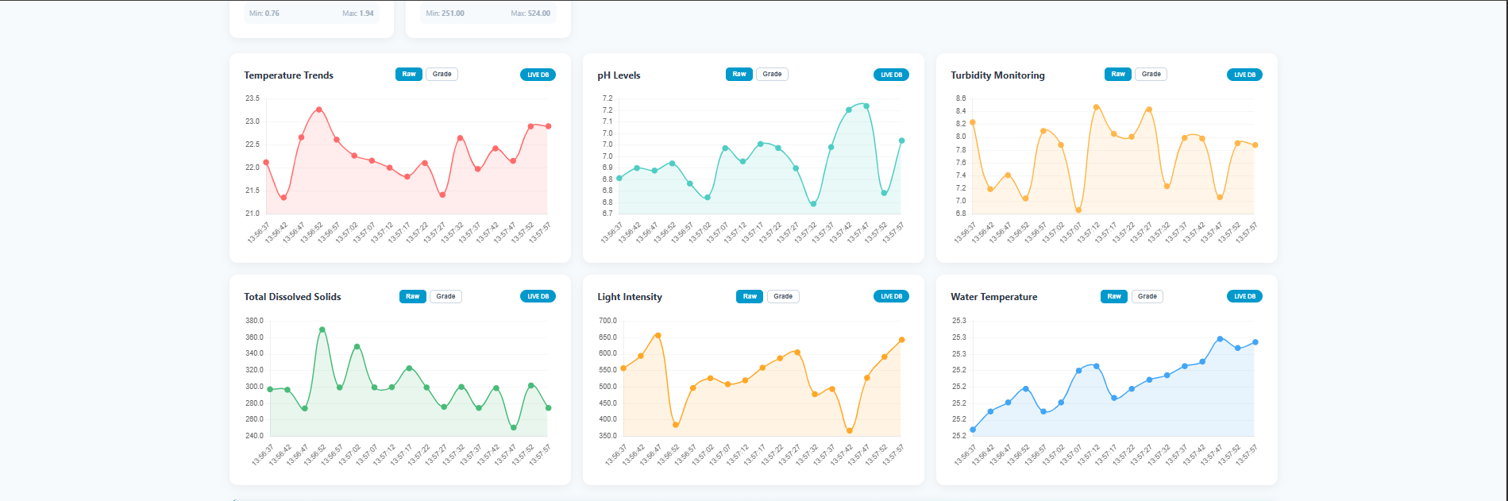
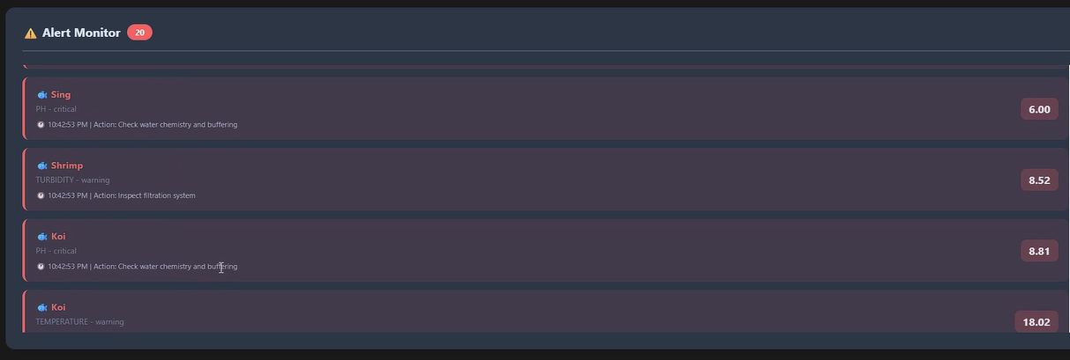
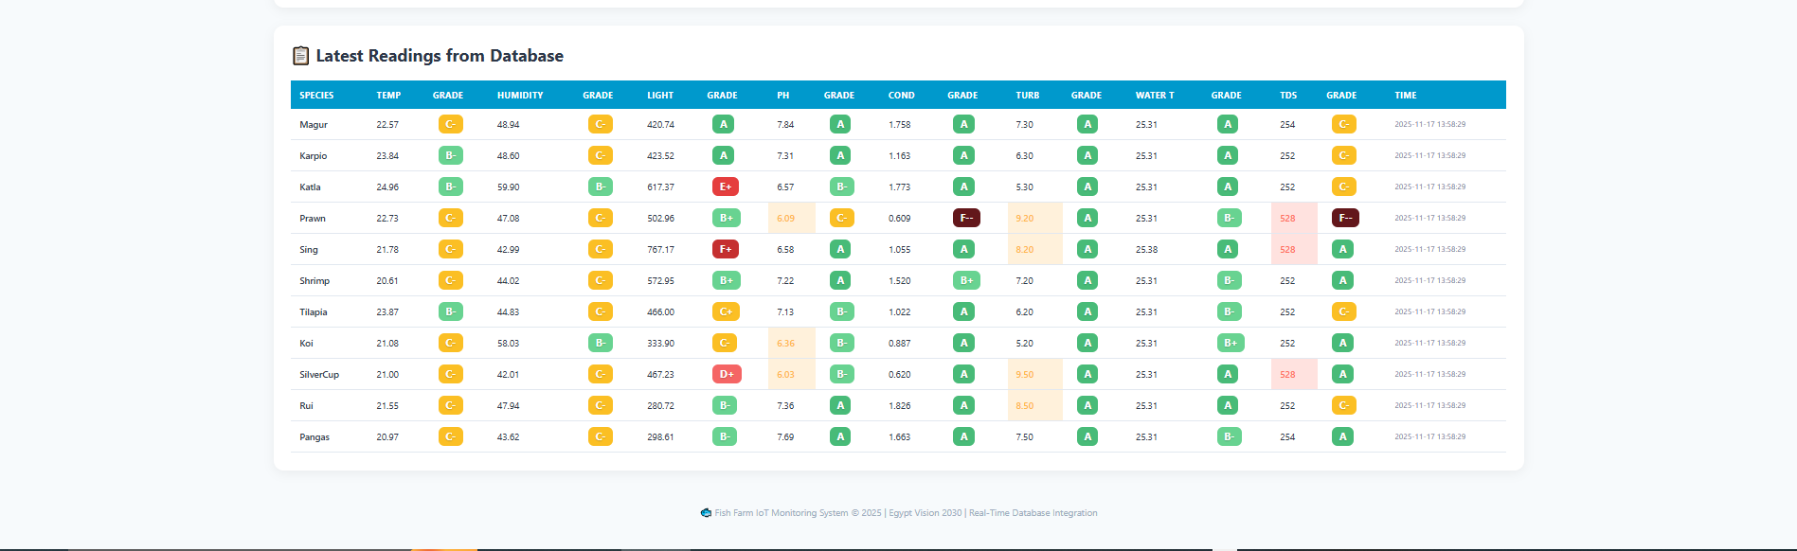

Conclusion
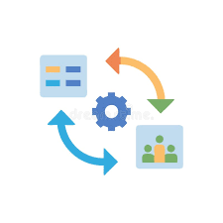
Throughout the entire project, we followed an iterative approach, continuously testing and improving each phase before moving to the next. Regular team discussions helped align the technical direction with the overall goals of Egypt’s Vision 2030 — promoting sustainability, efficiency, and innovation in smart agriculture.
By the end of the project, the team successfully delivered a fully functional IoT data pipeline that covers all aspects of data flow — from simulation and processing to visualization and decision-making.

